IN THE CIRCUIT COURT OF THE CITY OF ST. LOUIS
STATE OF MISSOURI
VANESSA MEADOWS,  Plaintiff,  v.  THE WASHINGTON UNIVERSITY,  Defendants. | )  )  )  )  )  )  ))  ) | Case No. 2322-CC09668  Division 1
DEPOSITION OUTLINE - KIMBERLY NASH

Overview:

PREFATORY QUESTIONS
Name (Full Legal)

Date of Birth

Employed/Position

Home Address

Business address/email address/phone #

Have you ever been arrested?

Have you ever been found guilty or pled guilty, or no contest, to any criminal charge?

Have you ever been a party to any case in court: sued someone, been sued by someone.
Basics
I ask questions, you answer truthfully, to the bets of your recollection and ability. Let me finish, verbal responses,ask for clarification.
But if you don’t ask for clarification, I’ll assume that you have understood the question.

If at any time you want to take a break, we can take a break, unless there’s a question pending - in that case you need to answer the question first and then we’ll get you a break.

You understand as we take breaks that you will remain under oath during the course of this deposition, right?
Are you under the influences of any substances or medications that might hinder your ability to recall facts or answer questions accurately today?

Can you think of any other reason why you might not be able to answer questions accurately today?

Is there any reason why your deposition should not go forward today?

Where are you located right now?

Anyone else in the room with you?

Do you have any other windows open on your computer?

Any documents in front of you?

Any notes / notepad?

Do you use social media, such as Facebook, Twitter, or Instagram?

If so, what names/handles do you use?

Have you ever complained about or commented about work or other employees on your social media?

NEW Ex. _ - LinkedIn (PDF is linked)
What is your personal email address?

If you have multiple, what are they?
Are you represented by counsel here today?

Who is your counsel?

Meet to prepare?

How long?

How many times?

Anyone else present?

What documents did you review?
Have you testified in any other cases?

Ones involving Wash U?
What’s your highest level of education?

Job duties, supervisor, supervisees, etc
What is your personal phone number?

Work number - different or same?

Does Wash U provide you with a phone?

Do you use it to make phone calls at work?

Text coworkers?

Tell me about all of them.

When was your last communication with:
- Lanelle Coleman
- Kimberlee Hanewinkel
- Jenifer Ellner
- Cody Dayton
- Jimi Baudino
- Doug Easler
- Emily Honeyball
- Mary Portell
- Anyone else involved in this case?

Did you use an internal messaging system at work? (CSS? others?)

Do you delete messages from these systems? Auto-delete?

Does it keep everything - for all time?

How long does it keep things for then?

Rules of the Road/Policies

Ex. 37 - WASH U 133-210 - Wash U School of Medicine Handbook
Page 58 of PDF (Bates 190).
- Approved November 2018 Correct?
- Familiar.
- Did Wash U provide you any training on this policy?
  - When, why, how many times
- Page 8 of PDF (Bates 140)
  - Wash U’s employment policies.
  - Wash U is an Equal Opportunity employer correct?
    - What does that mean?
  - Individuals with Disabilities section
    - Links to this page:
      - https://hr.wustl.edu/items/accommodation-process-for-disabilities-and-pregnancy-related-conditions/

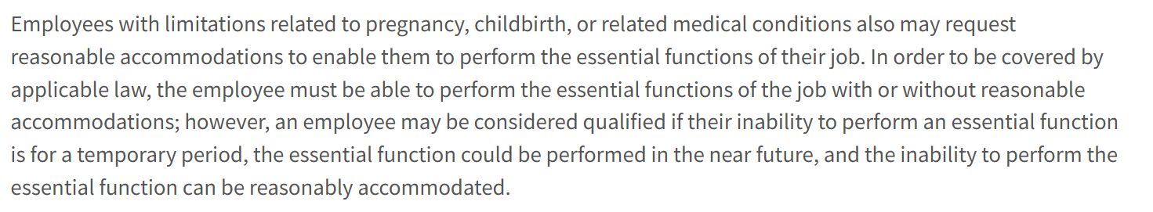
- Full page linked here:
- Ex. _ - Accomodation Process

How would you define the word “discriminate”?
- Would you agree that it means to “treat differently?”
- Do you understand that treating employees differently in the terms or conditions of their employment is illegal discrimination if a person’s age, race, or disability plays a part in the different treatment?
- Do you agree that age discrimination is wrong?
  - Is it ever okay to assume someone will or should retire based on their age?
- Do you agree that disability discrimination is wrong?
- Do you agree that race discrimination is wrong?
  - Do you agree that it is never appropriate to fire an employee because of their knee arthritis?
    - Do you agree that it is never appropriate to fire an employee because they requested reasonable accommodation for their knee arthritis?
  - Do you agree that it is never appropriate to fire an employee because of their race?
  - Do you agree that it is never appropriate to fire an employee because they are an older employee?
- Does Washington University have policies and practices that require discipline to one who engages in discriminatory conduct?
  - Why do those policies exist?
    - Would you agree also that those policies could subject Washington University to liability if they failed to take action once it knew about it?
- Would you agree that it is important to stamp out discrimination from the work place, whether it exists from co-workers or management itself?
- Would you agree that discrimination is still a problem; still exists?

Page 17, Bates 149 (employee benefits)
- Wash U offers quite a few benefits correct?
- Familiar with the different benefits offered to employees?
- What type of benefits does Wash U offer?
- That’s a lot. Do you agree Wash U is a good place to work?
  - Would you agree Wash U offers many lucrative career opportunities - the chance for advancement, well being, benefits, job security?
  - Would you agree that if a Wash U employee loses a career opportunity with Wash U, that loss has real value that translates to dollars and cents.
  - Would you agree that no one should suffer destruction of their career through the wrongful, illegal conduct of someone else? And if they do, that could deserve compensation?

—-> benefits
- Ex. 37 - WASH U 133-210 - Wash U School of Medicine Handbook
  - PAGE 32 Bates 164-166: Leaves of Absence
    - 164-165: Family and Medical Leave
      - The University recognizes that employees occasionally need to take time away from work to care for important family and medical needs. The Family and Medical Leave Act (FMLA) allows eligible employees to take up to 12 work weeks of unpaid job-protected leave in a rolling 12-month period (measured backward from the date requested leave will be used) for the following reasons:
        - 1. Employee Medical Leave - defined as time off due to a “serious health condition” of the employee (including the birth of a child), as certified by a health care provider.
    - The FMLA also allows an eligible employee to take up to 26 workweeks of unpaid job-protected leave in a 12-month period to care for a spouse, child, parent or next of kin who is a member of the Armed Forces (including a member of the National Guard or Reserves), and who suffers certain serious injuries or illness in the line of active duty (military caregiver leave).
    - Employees may be eligible for Short-Term Medical Disability (STMD) for absences related to their own medical conditions. Refer to the STMD policy for details. Employees are required to use accrued time off (sick and/or vacation) while on FMLA leave. Once sick time and vacation are exhausted, a portion of any remaining time on leave will be without compensation. An employee on an unpaid leave of absence, with the exception of unpaid FMLA, is not eligible for paid holidays.
  - PAGE 33 Bate stamped 165-166: Non-FMLA Leave
    - Non-FMLA Leave
      - It is the policy of Washington University to consider an employee’s request for medical or caregiver/parental leave of absence, where the leave does not qualify for protection under the Family and Medical Leave Act (FMLA) in accordance with guidelines set forth below. This policy generally provides up to 14 weeks of leave in any rolling 12-month period unless otherwise required by other applicable laws.
      - ELIGIBILITY
        - Benefits-eligible employees working 20 or more hours per week are eligible for leave under this policy. Eligible employees may request Non-FMLA leave if:
        - 1) They do not meet the FMLA eligibility requirements due to years of service, job status or number of hours worked in the preceding 12 months, or they have exhausted their twelve-week FMLA entitlement, and
        - 2) The leave request is due to personal medical or family medical, caregiver or parental needs.
      - DESCRIPTION OF BENEFIT
        - The maximum amount of Non-FMLA leave is 14 weeks within a rolling 12-month period. During leave, employees will be required to use their available accrued unused sick and vacation balances.
        - Non-FMLA leave is not job-protected; an employee’s position may be filled during their leave. The department may notify employees at the beginning of their leave of an intent to hold the position, but retains the right at any time during the leave to fill the position should the business need arise.
      - REQUESTING A LEAVE
        - Where the need for a leave of absence is foreseeable, employees are required to request the leave at least 30 days in advance. For unforeseen events, employees are required to request the leave as soon as it is possible and practical to do so. This leave may be granted with the approval and at the discretion of departmental management. Employees may be required to submit documentation that supports the need for the leave and the expected duration of leave.
        - Generally, Non-FMLA leave requests follow the exhaustion of other applicable leaves for which the employee might be eligible.
        - Employees may be required to complete a Non-FMLA Leave Application Form and submit appropriate supporting documentation as necessary. Human Resources will work with the department in determining whether to approve the leave. Requests will be reviewed on an individual basis, in consideration of job requirements and departmental needs and resources.
  - Page 35 Bates 167-168: Personal Leave
    - The University may provide an unpaid personal leave of absence, where the leave does not qualify for protection under the Family and Medical Leave Act (FMLA), and is otherwise ineligible or has exhausted other leaves such as the University’s Short-Term Medical Disability, Caregiver/Parental or Non-FMLA policies and has exhausted sick and vacation time off balances.
    - ELIGIBILITY
      - Benefits-eligible employees working 20 or more hours per week are eligible for leave under this policy.
      - Employees must be in good standing (not have received a formal written Performance Improvement Plan or Corrective Action within the last 9 months). This leave may be granted with the approval and at the discretion of management.
    - POLICY PROVISIONS
      - An employee may request up to 12 months of unpaid personal leave once all other leave options and time off balances are exhausted. Because the leave is unpaid, sick and vacation time off does not accrue through the course of this leave. Time off accruals will restart upon the employee’s return to paid status.
      - Benefits eligibility continues and the employee remains financially responsible for the cost of benefits.
      - Deductions that are not taken due to lack of pay are held in arrears and taken when the employee returns to work.
    - REINSTATEMENT FROM LEAVE
      - Employees who take personal leave are not guaranteed reinstatement to their position. The department should notify employees at the beginning of the leave whether the department intends to hold their position, though management retains the right at any time during the leave to decide not to hold the position.

CAST OF CHARACTERS

Kimberlee Hanewinkel

Who is Kimberlee Hanewinkel? What was her role at Wash U?

Relationship with her?

How long have you worked together?

Friends?

Supervisory / other role w/r/t Kimberlee Hanewinkel

Did the two of you ever communicate by email? Text? Phone? Slack? Teams? How else did you communicate when you communicated about work? Did you ever discuss your personal lives? By what mediums?

Same questions for Cody Dayton

Same questions for Jenifer Ellner

Same questions for Jimi Baudino

Same questions for Lanelle Coleman

Same questions for Doug Easler

Same questions for Emily Honeyball

Same questions for Mary Portell

TIMELINE OF DECISION
- Ex. 75 - WASH U 86
  - Margo Doherty emails Kimberly Nash
  - “Hello Kim,
  - In reviewing the above employees absence calendar and Unum, STMD has been approved through 07/12/22 and FMLA
  - has exhausted as of 06/02/22. The employee will need NFML paperwork for 06/03/12 through 07/12/22.
  - Should you have any questions, please let me know.”
- Ex. 43 - WASH U 88-89
  - 06/10 email Nash to Hanewinkel, CC Easler
    - According to information received from UNUM, Vanessa Meadows has been approved for STMD. (03/15/22 – 07/12/22) . However, a portion of his time was not approved for FMLA due to reaching FMLA exhaustion on 06/02/22.
    - Please indicate the department’s decision regarding the application of Non-FMLA Medical Leave to the dates of 06/03/22 to 07/12/22.
      - 1. Will the department grant the time away?
      - 2. Will the position be held during the time away?
    - If for some reason the department does not approve the application of NFML to this time, it will not be approved leave time and subject to the department’s attendance policy. Please Advise.
  - 06/10 email Hanewinkel to Nash, Easler, Ellner, Dayton
    - I discussed this with Jen Ellner and Cody Dayton. We will not grant additional time away. I spoke with Vanessa today and told her that she will need to return to work on 06/13/2022 or we will have to consider this her resignation. Vanessa said that she wanted to discuss returning to work with her doctor and would call me back today. I will give you an update as soon as I hear back from Vanessa.
  - 06/10/22 email Nash to Coleman
    - Seems to be forwarding the previous emails
    - I am just sending you this as a heads up so that you are aware.
    - Let me know if you need me to do anything.
- Ex. 45 - WASH U 90-92
  - Coleman email to Hanewinkel after this thread (NASH NOT INCLUDED)
  - I spoke to Vanessa Meadows this afternoon. She doesn’t want to resign or retire and I don’t think she understands that her employment is going to end, as she won’t be released to return to work until at least July 13, 2022. I explained that the department doesn’t have to hold her position open now that the FMLA has expired, and it can make a decision to end her employment.
  - If the position isn’t being held, you’ll need to generate a separation letter and inform her of the decision and pending letter. A draft is attached and you’ll need to fill in the date for the final paycheck as well as the signature block. The signed document should be sent to Emily Honeyball so she can process the separation.
- Ex. 47 - WASH U 98-99
  - 06/13/22 email Hanewinkel to Nash, Easler, Ellner, Dayton
    - Vanessa has decided to not return to work and will retire.
  - 06/23/22, Nash forwards email to Margo Doherty
    - Hello Margo
    - FYI…
    - Thanks
- Ex. 48 - WASH U 102-132
  - P. 105: “Finally, Ms. Meadows does not even attempt to offer any basis for her race discrimination claim, which is entirely conclusory and would not even survive an initial motion to dismiss for failure to state a claim. Moreover, the department worked closely with Human Resources representatives Lanelle Coleman and Kimberly Nash (who also are Black) in addressing Ms. Meadows’s employment situation, which further belies any unlawful motivation.”
- Ex. 44 - WashU 0488-489 - Coleman Notes
  - 489
    - 06/15, 10:39am
    - Kimberlee Hanewinkel/Ortho
    - “Vanessa Meadows term letter. Also called her to say 6/17 is her last day. Will update later and send it to her.”
  - What was the substance of this conversation? What did you say to Ms. Coleman? Why was 6/17 to be her last day?
  - Did she tell you that she was surprised? That she had talked to Meadows, who was insisting that she did not want to retire or resign?
    - Did that surprise you? Did you follow up w/ Meadows about this
- Ex. 49 - Wash U 346-359 - Hiring Paperwork for Vanessa’s Replacement
  - Active candidates: 1
  - Recruiting Start Date: 11/23/2022
    - Recruiting didn’t even start until over 5 months after Vanessa’s firing
    - Her replacement, Kortnie Scronce, didn’t apply until 12/04/2022

Me-Toos/Comparators

- Ex. _ - WASH U 1047-1048
  - Denisha Morgan Charge of Discrimination
  - Disability & Retaliation, Denial of Reasonable Accommodations
  - 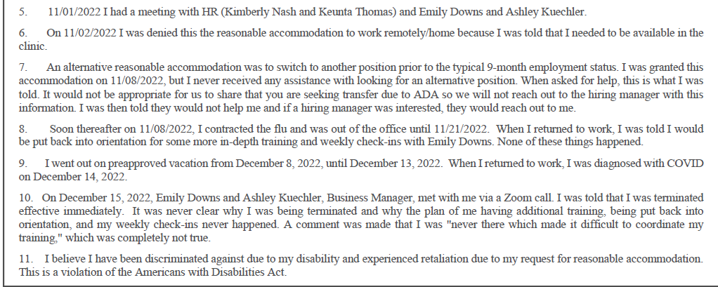

- Ex. _ - WASH U 1051-1056 - Chelsea Elder Charge of Discrimination
  - Sex, Disability, Retaliation
  - Not eligible for FMLA, denied NFMLA
  - Below is 1056:
